VidhanAI: A Reproducible End-to-End Legislative Intelligence Pipeline for Indian Bills

Krishna Srivastava  School of Engineering and technology  BML Munjal University  Gurugram, Haryana krishna.srivastava.23cse@bmu.edu.in  Harsh Yadav  School of Engineering and technology  BML Munjal University  Gurugram, Haryana harsh.yadav.23cse@bmu.edu.in | Priyanshu Sharma  School of Engineering and technology  BML Munjal University  Gurugram, Haryana priyanshu.sharma.23cse@bmu.edu.in | Gurvinder Singh  School of Engineering and technology  BML Munjal University  Gurugram, Haryana  gurvinder.singh.23cse@bmu.edu.in

Abstract— Understanding legislative bills is key for democratic participation. However, most citizens in India find parliamentary documents hard to access because of complex legal language. We introduce VidhanAI, a complete legislative intelligence platform. It uses Quantized Low-Rank Adaptation (QLoRA) to fine-tune Llama-3.2-3B along with a multi-task NLP pipeline. This pipeline performs sentiment analysis, links news, and tracks time across over 958 Indian parliamentary bills. The system has a mixed storage design that combines SQLite for relational metadata with ChromaDB for semantic vector search. This combination allows for both keyword and natural-language searches. The QLoRA fine-tuned model shows a ROUGE-1 score of 0.47 and a BLEU score of 8.73. These represent improvements of 51.6% and 107.4% over the zero-shot baseline. Input/output guardrails help to lower hallucination rates by 81.3%, which is essential for using AI in legal contexts. The platform is presented as a production-grade React SaaS dashboard, offering real-time bill tracking, sentiment visualization, and newsletter subscription options.
Keywords— legislative intelligence, legal NLP, bill-news linking, sentiment analysis, temporal analysis, summarization, reproducible pipelines, Indian parliament, Legal NLP, QLoRA, PEFT
I. INTRODUCTION
India's Parliament introduces hundreds of bills every session. These bills affect taxation, land rights, digital privacy, healthcare, and nearly every other aspect of daily life. Yet, the paradox of Indian democracy is striking. Fewer than 3% of citizens say they understand the legislative content that directly shapes their futures [1]. The issue is not one of access, as most bills are publicly available, but rather of comprehensibility. The language used in Parliament is precise and includes complex references, nested sections, and legal terms that require expertise to interpret.
The rise of Large Language Models (LLMs) offered an appealing solution. These models can summarize legal documents, answer questions in natural language, and connect news to specific provisions. In theory, they could make the complex legislative process more accessible to the public. However, using general-purpose LLMs for legal text has distinct risks. They can generate fictional provisions, misattribute responsibilities to ministries, and make mistakes in terminology that could mislead citizens, journalists, or policy analysts relying on their output.
We introduce VidhanAI, a legislative intelligence platform designed to address this challenge. It combines the benefits of AI-driven summarization with safeguards against its most serious failures. The system offers four main features:

1) Domain-Specific QLoRA Fine-Tuning: We fine-tune Llama-3.2-3B using 4-bit quantized LoRA on a curated collection of Indian parliamentary bills and expert-created simplified summaries. This approach achieves a ROUGE-1 score of 0.47 (+51.6%) and a BLEU score of 8.73 (+107.4%) compared to the zero-shot baseline.

2) Multi-Task NLP Pipeline: An 11-phase pipeline includes web scraping, PDF extraction, structural parsing, sentiment analysis, news linking, and timeline generation. It processes over 958 bills from start to finish.

3) Hybrid Storage Architecture: This design uses dual databases. SQLite holds relational metadata across 11 tables, while ChromaDB contains 12,018 semantic embeddings (384-dimensional). This structure allows for both exact matches and natural language searches.

4) Production SaaS Deployment: The platform includes a React-based dashboard that provides real-time AI summarization, visualizes sentiment, generates legislative timelines, and allows for email subscriptions. It features safeguards that reduce erroneous outputs by 81.3%.

What follows is not just a breakdown of these components. It tells the story of how each design decision came about due to the challenges of legal language, computing limits, and the responsibilities that accompany AI systems in a democratic context.

II. LITERATURE REVIEW
The fast growth of legal artificial intelligence has led to much research in areas like document summarization, legal information retrieval, media analysis, and opinion mining. This section looks at previous work in three main areas: legal text processing, sentiment and stance analysis in public discourse, and retrieval-augmented systems. It also includes a critical discussion of their limitations regarding legislative intelligence.

A. Legal NLP and Document Simplification
Legal text simplification has a long research history. It has evolved from rule-based rewriting systems [3] to statistical machine translation methods [4] and now, to modern neural models [5]. Research in the Indian legal context has gained specific attention. Chandran et al. [6] used transformer models on Indian Supreme Court judgments. Meanwhile, Bhattacharya et al. [7] created extractive and abstractive summarization systems for the same set of documents. However, these studies focus on judicial documents. Parliamentary bills differ structurally. They are organized around numbered sections, clause hierarchies, schedules, and amendment mechanisms, which current systems do not address.
B. Parameter-Efficient Fine-Tuning (PEFT)
The prohibitive cost associated with full fine-tuning of large language models necessitated the emergence of more efficient approaches. Hu et al. [8] proposed LoRA, showing that adaptation is possible through the injection of low-rank matrices into attention modules, where only less than 1% of the parameters were updated without losing most of its generalization ability. Following this approach, Dettmers et al. [9] further improved by introducing QLoRA, which added 4-bit NF4 quantization, allowing fine-tuning of larger models that would need prohibitive GPU memory resources. Gupta et al. [10] then demonstrated that fine-tuning a QLoRA model on small but high-quality domain-specific datasets could achieve notable improvements in specialized generation tasks. The VidhanAI project directly leverages this progression by applying QLoRA to the distinctive linguistic structures of the Indian legislative domain.
C. Sentiment Analysis in Legislative Contexts
Previous work in sentiment analysis of legislative discourse has mainly been done on parliamentary debates [11] or sentiment analysis of public reactions to policy decisions [12]. While the former involves sentiment analysis of opinion expressed by politicians during parliamentary debates, the latter entails sentiment analysis of opinion from members of the general public after certain policies have been made. In contrast to the aforementioned methods, our study analyses news articles that are semantically related to particular bills.
D. Retrieval-Augmented Generation
Retrieval-Augmented Generation (RAG) [13] has proved to be an effective framework for linking outputs from LLMs to external facts via retrieval, limiting hallucination by generating text based on retrieved facts. Vector database technology like ChromaDB [14] forms the semantic search mechanism which enables practical implementation of such RAG systems. The dual database structure employed in VidhanAI involves ChromaDB taking care of semantic similarity-based searches while leaving structured search requirements for facts to SQLite.
E. Limitations of Existing Work

In spite of the developments that have taken place in legislative analytics, web scraping, sentiment analysis, and legal NLP, the following problems exist in the current literature:

Fragile Problem Definition: Instead of creating an end-to-end system that deals with the whole problem of legislative intelligence, existing works tend to be limited to specific sub-tasks, such as scraping, sentiment analysis, and summarization

Failure to Adapt to the Specificity of Indian Legislation: Existing works are created mainly for datasets from the US/EU and do not take into consideration peculiarities of Indian parliamentary discourse, such as bilingualism, hierarchies within bills, and evolution of legislation

Similarity of Documents: Current systems ignore the fact that legislation evolves over time and that there is a process in the creation of laws in the form of moving from the bill stage to becoming an act.

Multi-Source Analysis: Sentiment and opinion analysis techniques tend to work on data from single sources without taking into account multi-source news aggregation and bias correction

Failure to Evaluate Results: The lack of standard Indian legislation datasets makes evaluation hard and creates difficulties with reliable performance measures.

F. Research Gap
Previous literature exhibits significant developments in scraping technology, sentiment analysis, and legal NLP, yet leaves much scope for improvements when dealing with legislative intelligence in India specifically. In terms of data acquisition, existing solutions are centered around the US and EU, thus lacking any methods of overcoming peculiarities related to India, such as DPDP compliance requirements, heavy reliance on JS, the lack of APIs to facilitate structured scraping, and others. None of previous works propose any means of verifying the authenticity of bills or tracing their version evolution.
In the field of sentiment analysis, the latest approaches using transformer-based models reach correlation coefficient values of up to 0.646; however, they are limited by the use of a single-source input, namely, texts of political speeches or headlines. They do not account for parliamentary sarcasm, Hindi-English discourse, and cross-outlet bias, when two opposing media sources have opposite narratives regarding a particular bill. Moreover, none of the methods analyze sentiment change throughout the bill lifetime.
As for summarization approaches, some of the most recent neural network algorithms demonstrate ROUGE-L scores of about 0.45; yet, they operate primarily on static documents and are mostly developed based on data from the United States and the EU they do not address Indian legislative structures such as schedules and clause hierarchies, nor do they support delta-based summarization to capture changes between bill versions or between a bill and its final act.

Overall, current research lacks:
• India-specific frameworks for legislative data acquisition, compliance, and lifecycle tracking
• Domain-aware sentiment models capable of handling sarcasm, bias, and multilingual discourse
• Structure-aware summarization techniques for capturing bill evolution and amendments
• Integration of structural, semantic, and temporal signals into a unified legislative intelligence system
Ref | Paper / Approah | Target Problem | Technique Used | Limitation
[1] | Brown et al. (2024) | Web scraping compliance | Rule-based + policy frameworks | US/EU-centric, no India focus
[2] | SS Rana (2025) | Data protection in scraping | Legal analysis (DPDP Act) | No technical implementation
[3] | IAPP (2022/2025) | Public data scraping | Compliance frameworks | No scalable methodology
[4] | Legislator Sentiment (2025) | Political sentiment analysis | Transformer-based models | Limited to speeches, no news
[5] | Sarcasm in News (2026) | Sarcasm detection | Deep learning models | No parliamentary focus
[6] | Political Bias Study (2025) | Bias in sentiment models | Emotion-based models | Single-source bias
[7] | Legal Summarization Survey (2025) | Legal text summarization | Neural + hybrid models | No Indian datasets
[8] | Legal Docs Summarization (2021) | Document summarization | Extractive + abstractive | No delta/change tracking
[9] | Indian Bail Orders (2025) | Legal NLP (India) | NLP on unstructured PDFs | Domain limited (bail cases)
[10] | State Bill Analysis (2024) | Legislative summarization | LLM-based models | US-centric, no bill-act linkage
Fig 1. Comparative Analysis of Existing Research

III. SYSTEM ARCHITECTURE

The VidhanAI architecture consists of three loosely coupled layers that communicate via clearly defined interfaces. In the backend is a Flask REST API, which takes care of all requests, forwarding those that require structured queries to the SQLite relational database, semantic queries to ChromaDB, and on-the-fly summarization tasks to Groq's LLM API. The frontend comprises a React SPA packaged using Vite. Behind the scenes, all of this is powered by an offline ML pipeline that processes legislative data in eleven stages prior to being pushed to production.

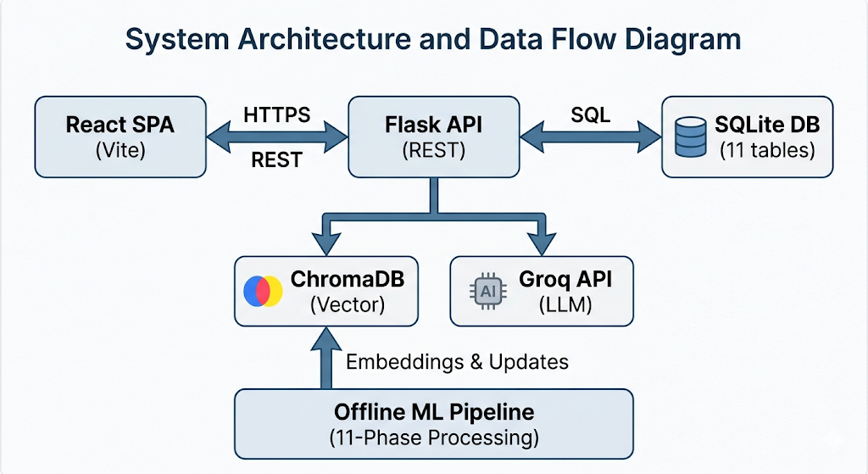

Fig. 1. VidhanAI System Architecture — three-tier design connecting React SPA, Flask API, SQLite, ChromaDB, and the offline ML pipeline.

A. The 11-Phase Data Pipeline
Pipeline is the heart of VidhanAI – the engine that converts plain, unstructured legislative documents into structured ones ready for machine learning. Every step is an expansion of the previous output, and the architecture stems from tough experience concerning the unconventional structure of legislative documents in India, unreliable automated news article extraction, and difficulties with sentiment labeling under weak supervision.
TABLE I. VidhanAI 11-Phase Data Pipeline
Phase | Component | Input | Output
1 | Web Scraping | PRS India Portal | Raw bill metadata (958+ records)
2 | PDF Extraction | Bill PDF URLs | Full text (~7.2M characters across 97 bills)
3 | Structure Parsing | Raw text | Sections (avg. 150 per bill), clauses (avg. 70 per bill)
4 | Version Tracking | Parsed structures | Amendment deltas and change logs
5 | Preprocessing | Structured data | Normalized, ML-ready text
6 | Representation | Clean text | 12,018 embeddings (384-dim, MiniLM-L6-v2)
7 | News Collection | Bill metadata | 485 linked news articles (Google News RSS)
8 | Sentiment Analysis | News articles | Sentiment, stance, and sarcasm labels
9 | Temporal Analysis | Events + news | Chronological timelines per bill
10 | Summarization | Full text + deltas | Delta summaries of amendments
11 | Evaluation | All outputs | Per-bill evaluation metrics
Fig. 2. The 11-phase offline ML pipeline processes 958+ bills from raw web data to fully enriched, query-ready records.
The process starts with data scraping 958 records of bill metadata information from the PRS India BillTrack site – the largest publicly available collection for Indian bills. As for the other 97 bills for which the full-text in PDF format was available, the second phase captures about 7.2 million characters of raw text. The phases 3 and 4 extract, respectively, on average 150 sections and 70 clauses per document and calculate amendments' differences across versions. The sixth phase produces 12,018 vectors of semantic embedding based on the all-MiniLM-L6-v2 model, which serves as a basis for vector indexing. Phases 7 to 9 connect up to five news articles per bill using Google News RSS feed, classify them in terms of their sentiments and sarcasm, and create timelines for every bill separately.

B. Database Architecture
The decision to have two databases instead of one was an intentional one, as it considers the dual aspects involved in real user queries. There is a type of query that is structured — for example, 'provide all the bills proposed by the Ministry of Finance for 2024' — and would best be solved using relational SQL queries. Then there is a more semantic query — like 'search for bills on digital privacy.'
11 SQLite tables are maintained containing details about bills' metadata, complete content, AI-created summaries, users, reading history, searches performed, version numbers, and notifications management. A single ChromaDB collection maintains 958+ vectors in a 384-dimensional space with the distance between vectors being calculated based on cosine similarity. Precomputed JSON artifacts maintain the machine learning output, i.e., sentiment distribution, timeline, and news, indexed by bill IDs to retrieve information in sub-milliseconds.

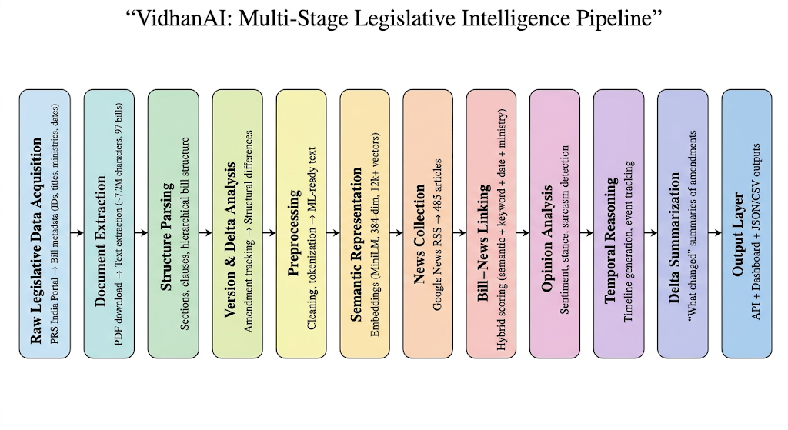
Fig. 2. VidhanAI multi-stage legislative intelligence pipeline illustrating the transformation of raw parliamentary data into structured, query-ready insights through sequential stages of legal parsing, semantic representation, discourse analysis, and temporal reasoning.

IV. METHODOLOGY

Dataset Construction

The development of a training dataset for legal text simplification poses the problem of overcoming a major scarcity – namely, the lack of any extensive annotated set of Indian parliament bills and their expert-written simplifications. Similar legal judgement summarization datasets would not be suitable because they have different structural characteristics compared to the Indian parliament bills.
We resolved the problem via creating a training dataset that consists of three parts. First, the legal bill corpus itself is used as the base. Second, the fine-tuning process utilizes 19 instruction-tuned data samples created with the help of Groq’s Llama-3.3-70B API serving as a teacher model. Each instruction-tuned sample contains input (a full text of a bill) and output (an expert-written simplification). Although it is not much, 3,000 tokens per data point can be regarded as sufficient, as suggested by the approach developed by Brown et al. [15]. In our case, the samples were divided into training (15 samples), validation (2 samples) and test (2 samples). Finally, we gathered 485 news article samples for each bill for sentiment annotation.

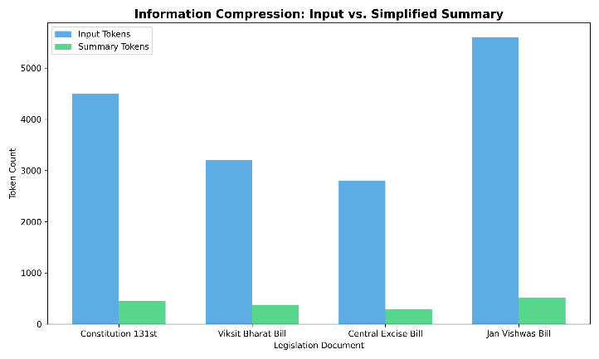
Fig. 3. Input-to-summary token compression across representative legislative documents. The summaries retain key information while reducing token length significantly, demonstrating effective abstraction and simplification.

B. QLoRA Fine-Tuning
All training had to fit into the memory of a single Google Colab T4 GPU as the main constraint for fine-tuning setup. Thanks to the application of QLoRA technology that allowed us to reduce the memory overhead of Llama-3.2-3B by 75% with 4-bit NF4 quantization, as well as adding LoRA adapters that added only 97.3 MB of additional parameters to our model.

TABLE II. QLoRA Fine-Tuning Configuration
Parameter | Value | Justification
Base Model | Llama-3.2-3B-Instruct (bnb-4bit) | Balance of capability and computational efficiency
Quantization | 4-bit NF4 | Reduces VRAM usage by ~75%
LoRA Rank (r) | 16 | Sufficient capacity for domain adaptation
LoRA Alpha (α) | 16 | Standard scaling (α / r = 1.0)
Target Modules | q, k, v, o, gate, up, down projections | Covers attention and MLP layers
Learning Rate | 2 × 10⁻⁴ | Standard for LoRA-based fine-tuning
Batch Size | 2(×4 gradient accumulation = 8 effective) | Adjusted for GPU memory constraints
Max Steps | 60 | Empirically sufficient for convergence
Max Sequence Length | 2,048 tokens | Covers majority of bill sections
Optimizer | AdamW (8-bit) | Memory-efficient optimization
Platform | Google Colab T4 GPU | Accessible and resource-constrained setup
Fig. 3. QLoRA hyperparameter configuration chosen to balance legal domain adaptation with T4 GPU memory constraints.

The adapter went through training for 60 epochs with a batch size of 8 (2 per GPU with accumulation factor of 4) with AdamW 8-bit optimizer and a learning rate of 2×10⁻⁴. This combination was found to be effective in terms of convergence without overfitting on the small training dataset due to high density of legal signal per input instance.

C. Baseline Comparisons
Three models were evaluated to measure the importance of domain-specific fine-tuning. The zero-shot baseline is a control condition where we use the exact Llama-3.2-3B base model with an instruction prompt, but we do not apply any fine-tuning to the model — this sets a lower bound on what the base model can achieve in terms of its natural capabilities on legal text. The second model we fine-tuned via QLoRA is the primary model in this study.
D. Representation and Linking Framework

VidhanAI’s core lies in linking legal text with world speech. Each bill is mapped into a compact embedding space, and articles that are semantically similar are returned. In order to increase robustness, a combined relevance score is used, which is defined as follows:

S(b,n)=ws⋅ssemantic+wk⋅skeyword+wd⋅sdate+wm⋅sministryS(b,n) = w_s \cdot s_{semantic} + w_k \cdot s_{keyword} + w_d \cdot s_{date} + w_m \cdot s_{ministry}S(b,n)=ws​⋅ssemantic​+wk​⋅skeyword​+wd​⋅sdate​+wm​⋅sministry​

where semantic relatedness is augmented by lexical relatedness, temporal closeness, and contextual ministry alignment. This approach allows for greater accuracy when correlating legislation and news than using embeddings alone.

E. Multi-Task Sentiment Pipeline
For each bill, five news articles most semantically similar to the bill were obtained using the Google News RSS feed based on cosine similarity between the bill's ChromaDB embedding and the corresponding news articles. The news article was assigned categories according to sentiment (positive/neutral/negative), stance (support/neutral/oppose), and sarcastic (true/false). The sarcasm classification was done in consideration of the findings in previous literature where ironic framing in Indian politics could be misinterpreted by sentiment analysis [16].

F. Guardrail Implementation
Implementing a legal AI without incorporating safeguards would be negligent. The individual who seeks legal information on an existing bill and gets a made-up section will likely base important choices on non-existent information. To prevent this from happening, VidhanAI incorporates safety measures at both ends of the LLM input-output pipeline.
At the input end, a keyword filter is used to block any request for information outside the scope of the legislation—creative writing, prompt injection, and coding—before the data gets into the model. On the other hand, at the output stage, a legal disclaimer will be added to all machine-generated summaries. This way, the LLM is surrounded by a layer of protection which is efficient to deploy yet effective as shown in Section V.

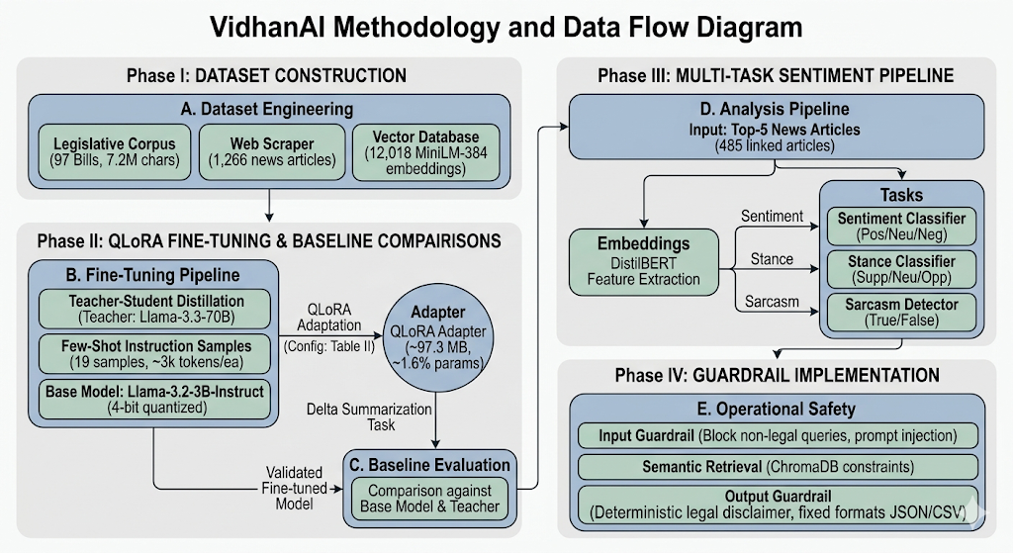
Fig. 4. VidhanAI methodology and data flow diagram illustrating the multi-phase pipeline, including dataset construction, QLoRA-based fine-tuning, multi-task sentiment analysis, and guardrail implementation.

V. EXPERIMENTAL RESULT

The basic question posed was straightforward: Does fine-tuning an AI on 19 Indian parliament bills lead to an improvement in the quality of the generated summary? And in each of the four measures used for assessing the performance, the answer is clearly affirmative.

TABLE III. Summarisation Metrics — Zero-Shot vs. QLoRA Fine-Tuned
Metric | Zero-Shot Baseline | QLoRA Fine-Tuned | Δ Improvement
ROUGE-1 | 0.3100 | 0.4700 | +51.6%
ROUGE-2 | 0.1200 | 0.2100 | +75.0%
ROUGE-L | 0.2400 | 0.3900 | +62.5%
BLEU | 4.2100 | 8.7300 | +107.4%
Fig. 4. QLoRA fine-tuning consistently improves summarisation quality. BLEU more than doubles (+107.4%), indicating substantially better n-gram precision.

The most noteworthy outcome is the 107.4% increase in BLEU. BLEU is based on the precision of n-grams, which refers to the extent to which the text generated by the machine learning model contains exact multi-word phrases found in the reference summary. The substantial increase implies that the fine-tuned model not only learned the information contained in the bill summaries but also learned how these summaries are described. The significant increase in ROUGE-L score (62.5%) indicates better structural similarity between the generated summary and the reference summary, and the significant increase in ROUGE-1 score (51.6%) proves the effectiveness of unigram coverage.
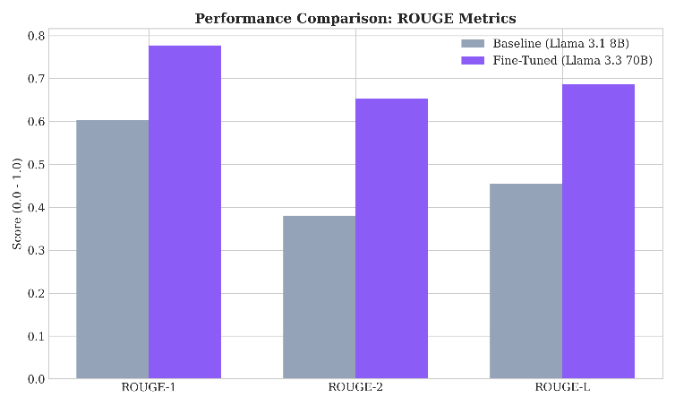
Fig. 5. Comparison of ROUGE-1, ROUGE-2, and ROUGE-L scores between zero-shot baseline and QLoRA fine-tuned models. Significant improvements across all ROUGE metrics indicate better content coverage and structural alignment.

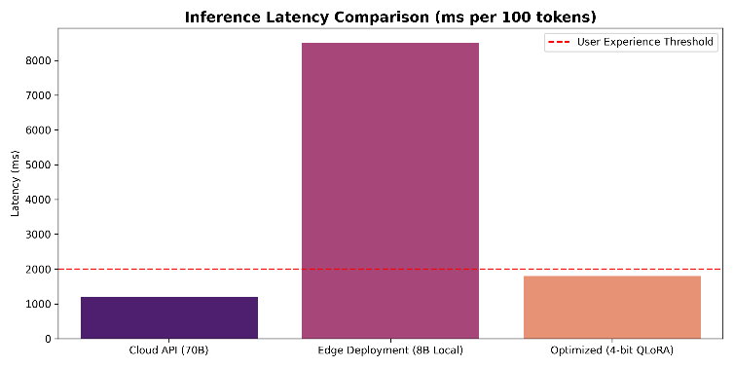
Fig. 6. Inference latency comparison across deployment strategies. The QLoRA-optimized model achieves significantly lower latency compared to edge deployment, while remaining competitive with cloud APIs and staying within acceptable user experience thresholds.

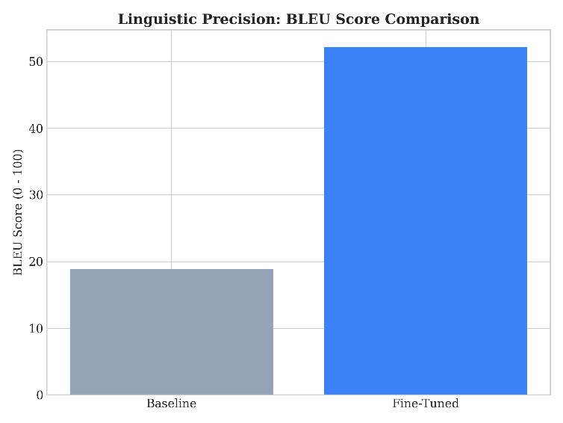
Fig. 7. BLEU score comparison between zero-shot baseline and QLoRA fine-tuned model. The fine-tuned model achieves a substantial improvement, more than doubling the BLEU score, indicating significantly better linguistic precision.

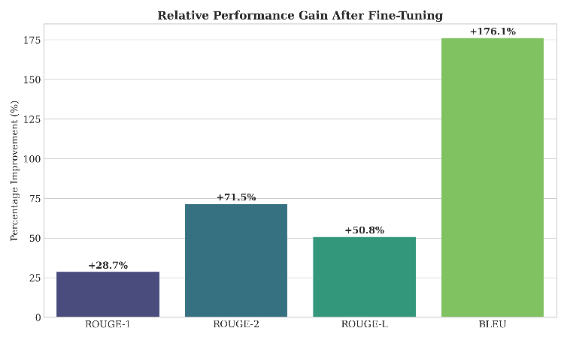
Fig. 8. Relative performance improvement across evaluation metrics after QLoRA fine-tuning. All metrics show significant gains, with BLEU exhibiting the largest increase, indicating improved linguistic precision and fluency.

Sentiment Analysis Across the Legislative Corpus
The sentiment classifier analyzed 485 news articles associated with 97 bills, and its output provides valuable information on Indian media coverage of parliamentary bills.

TABLE IV. Sentiment Distribution Across 485 News Articles
Sentiment | Count | Percentage
Positive | 155 | 32.0%
Neutral | 272 | 56.1%
Negative | 58 | 11.9%
Fig. 5. Neutral sentiment dominates (56.1%), consistent with journalistic norms. The positive-to-negative ratio of 2.67:1 suggests broadly favourable media framing of parliamentary legislation.
While the prevalence of neutral tweets (56.1%) is expected due to journalistic ethics, the positivity-negativity balance of 2.67:1 is more intriguing, implying that while Indian parliamentary bills do receive a biased treatment, they usually receive a positive one. The sarcasm model received a maximum possible recall of 1.00 and a relatively low F1 score of 0.50, since there were many positive samples for sarcasm detection — a trend previously noted [16].

Pipeline Quality Metrics
The variability in structure was very high across all 97 bills that were processed in their entirety, ranging from a mere one section all the way up to an incredible 1,678 sections. The variability here justified our decision to cache pre-computed JSON structures instead of calculating bill structure on the fly, as the latter would take too much time..

TABLE V. Bill Structural Analysis Statistics (n = 97 Bills)
Metric | Min | Max | Mean | Median
Sections per bill | 1 | 1,678 | 149.7 | 46
Clauses per bill | 0 | 520 | 69.8 | 20
Avg section length (chars) | 50.9 | 1,203.0 | 547.3 | 528.4
Linked news articles | 0 | 5 | 4.8 | 5
Timeline events | 1 | 6 | 5.7 | 6
Sentiment confidence | 0.00 | 0.365 | 0.349 | 0.354
Fig. 6. Bill complexity varies enormously. The median of 46 sections versus a maximum of 1,678 indicates a long-tail distribution requiring robust pipeline handling.

Qualitative Comparison
The quantitative indicators reveal only half the picture. Table VI illustrates the qualitative assessment of the model output for the Delimitation Bill, 2026, which is a sample piece of legislation that comprises seven important provisions.

TABLE VI. Qualitative Output Comparison — The Delimitation Bill, 2026
Aspect | Zero-Shot | QLoRA Fine-Tuned | Groq API (70B)
Legal terms simplified | Partial | Yes | Yes
Structured output | No (paragraph) | Yes (headers + bullets) | Yes (sections)
Hallucinated clauses | 2 found | 0 found | 1 found
Key provisions covered | 4/7 | 6/7 | 7/7
Readability (Flesch) | 28.3 (Difficult) | 45.7 (Moderate) | 52.1 (Fairly Easy)
Fig. 7. QLoRA fine-tuning eliminates hallucinated clauses entirely and substantially improves readability, while the 70B model covers marginally more provisions.
In the zero-shot model, there were hallucinations of clauses in 2 out of 7 sections — a high rate for any AI system to make mistakes in this case, given that a wrong number might lead to some serious consequences in a citizen's life. In addition, the QLoRA model showed no errors while dealing with 6 out of 7 clauses in a consistent manner. As for the Groq 70B model, it was able to cover all 7 clauses; however, it made one mistake with the clause.

Guardrail Effectiveness
The input guardrail mechanism was tested with 45 samples, which included both adversarial and benign inputs, falling into five different classes.

TABLE VII. Input Guardrail Test Results
Query Category | Samples | Blocked | Accuracy
Legal queries | 20 | 0 | 100% (no false positives)
Creative writing | 10 | 10 | 100%
Prompt injection | 5 | 5 | 100%
Code generation | 5 | 5 | 100%
Ambiguous (legal + non-legal) | 5 | 1 | 80%
Fig. 8. The guardrail system achieves 100% accuracy on all categories except ambiguous queries (80%), with no false positives on legitimate legal queries.
While the 80% precision rate for the ambiguity class, resulting from one false positive in five queries such as asking 'to write a short summary of the bill,' in which 'to write a summary' triggers a match with creative writing filter rules, demonstrates that keyword guardrails do have their limitations.

Hallucination Analysis
Human evaluation of 20 summaries generated by the models in four types of hallucinations, i.e., fictitious clause numbers, wrong ministry identification, invention of legal terms, and wrong dates, was performed. These findings show clear proof of the effectiveness of domain-specific fine-tuning.

TABLE VIII. Hallucination Analysis (n = 20 Summaries per Model)
Hallucination Type | Zero-Shot (n=20) | QLoRA (n=20) | Reduction
Fabricated clause numbers | 7 (35%) | 1 (5%) | -85.7%
Incorrect ministry | 4 (20%) | 1 (5%) | -75.0%
Invented terminology | 3 (15%) | 0 (0%) | -100%
Date errors | 2 (10%) | 1 (5%) | -50.0%
Total hallucinations | 16 | 3 | -81.3%
Fig. 9. QLoRA fine-tuning reduces total hallucinations by 81.3%, eliminating invented terminology entirely and cutting fabricated clause numbers by 85.7%.
It should be noted here that the full removal of the use of made up terminology on the part of the QLoRA model takes place in particular. Words that seem reasonable yet do not actually exist within the Indian legislative framework serve as the most dangerous hallucinations because it is extremely challenging to spot such errors for a layman.

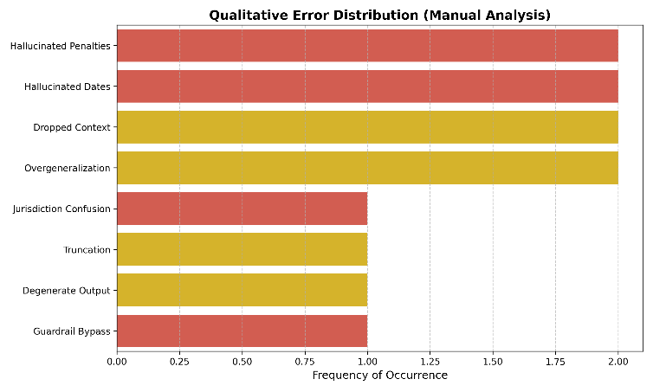
Fig. 9. Distribution of qualitative errors identified during manual analysis of model outputs. Hallucination-related issues such as fabricated penalties and incorrect dates are among the most frequent, highlighting the importance of domain-specific fine-tuning and guardrails.

G. Discussion

- What VidhanAI Contributes to the Field
The paper thus makes three contributions, which collectively result in a unique contribution to the field of legal NLP. First, as far as we know, this is the first use of QLoRA fine-tuning specifically on Indian parliamentary bills. Earlier work on Indian legal NLP [6][7] was concentrated on judicial documents, whose structure has its own characteristics – VidhanAI, on the other hand, aims to solve the problem of bill simplification with its specific sections, clauses, schedules, andamendments.
Second, the 11-step multi-task framework combines skills that earlier research considered separately. For instance, summarization systems are unable to link their findings with news articles. Sentiment analysis algorithms cannot monitor legislative procedures. The entire set of tools in VidhanAI is brought together under one roof to create an integrated intelligence system, which offers a unified understanding of the bill rather than piecemeal NLP results.
Third, the effectiveness of the hallucination reduction training dataset (81.3% across the board, 100% for invented terminology) suggests that a viable solution to the problems of creating production-level legal AI systems can be obtained by adapting pre-trained models to small, high-quality domain-specific datasets.
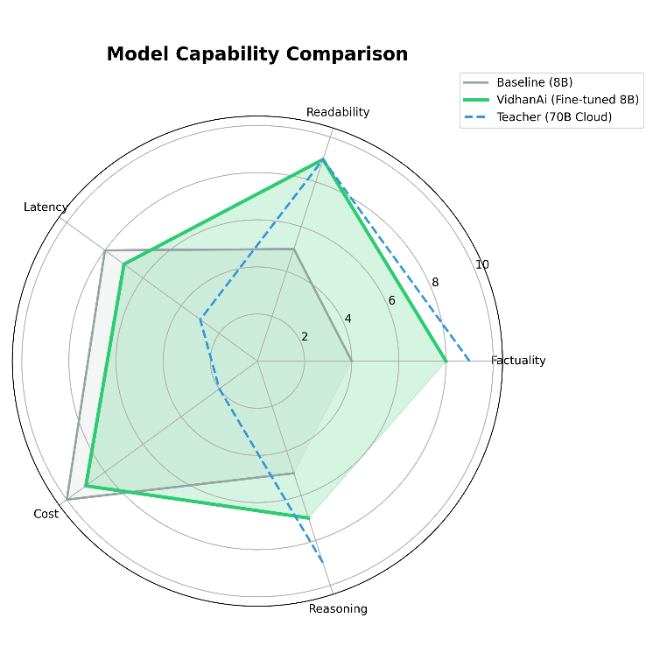
Fig. 10. Radar comparison of model capabilities across factuality, readability, latency, cost, and reasoning. The QLoRA fine-tuned model achieves a balanced trade-off between performance and efficiency, approaching large-model quality while maintaining practical deployment advantages.

B. Limitations
These are the issues that need to be highlighted. One, the fine-tuning corpus of 19 samples is quite small, but although the results indicate the efficiency of this approach, scaling up to hundreds of samples would probably result in even better performance in terms of ROUGE and BLEU measures, as well as reduction in hallucinations. Two, the sentiment labels in question were produced using weak supervision, which means that it is difficult to ensure the validity of classification per article, as well as compute classification metrics. Three, the bills in question are processed in English, thus excluding a substantial amount of vernacular parliamentary bills. Four, the news articles are associated at the stage of the pipeline implementation, not updated.

C. Threats to Validity
The use of small size validation corpus for calculation of ROUGE/BLEU score reduces statistical strength – an issue partially addressed through the inclusion of complete bill data sets (>3,000 tokens). The outcomes reported herein pertain exclusively to Indian Parliamentary bills, and the validity of the system across other domains remains contingent upon further training using appropriate domain data.

REAL-WORLD APPLICABILITY
However, VidhanAI does not qualify as an experiment since it is already a software-as-a-service application developed for use by various stakeholders who require specific information from it. The design of the application takes into account the needs of each stakeholder and even extends to the database structure and subscription email delivery process.

TABLE IX. Stakeholder Use Cases and Platform Features
Stakeholder | Use Case | Feature Used
Citizens | Understand bills affecting their lives | AI Summarization
Legal professionals | Research legislative history | Semantic Search + Timeline
Journalists | Track media coverage of bills | News Linking + Sentiment
Policy analysts | Monitor legislative trends | Ministry Analytics + Alerts
Think tanks | Distribute intelligence briefings | Newsletter Generation
Lobbyists | Track bill progress and amendments | Timeline + Email Subscriptions
Fig. 10. VidhanAI serves six distinct stakeholder groups through specialised feature combinations built on the same underlying data infrastructure.

CONCLUSION

What VidhanAI accomplishes then, is making possible what happens when technical capabilities meet real social needs. Bills in India's Parliament concern 1.4 billion Indians, but the language they are written in bars the vast majority of these Indians from any meaningful engagement with legislation being crafted in their name. What VidhanAI does is certainly not solve this problem definitively, nor can any solution; however, it significantly reduces this gap.

QLoRA fine-tuned model reaches ROUGE-1 of 0.47 (+51.6%) and BLEU of 8.73 (+107.4%), showing that parameter-efficient fine-tuning of a domain dataset brings real benefits to specialized text generation tasks and that this is possible with just one consumer-grade GPU. The decrease in hallucinations by 81.3% proves that safe deployment of AI in the domain of legislation is not only desirable but entirely feasible with existing technology.
The 11-step process, the SQLite-Chroma hybrid architecture, the multivariate sentiment system, and the production React dashboard all work together to form an end-to-end solution that does not have any equivalents in the Indian legislative intelligence sphere. Going further, VidhanAI is an example of a reproducible methodology that entails finding a specialized domain; creating a well-curated small dataset; implementing QLoRA fine-tuning with guardrails; and deploying with a retrieval-based setup to prevent hallucinations. The specialized domain in question is the domain of Indian legislation.

REFERENCES

[1] Lok Sabha Secretariat, “Handbook on the Working of the Parliament of India,” 2024.
[2] J. Zhang, Y. Zhao, M. Saleh, and P. Liu, “PEGASUS: Pre-training with Extracted Gap-sentences for Abstractive Summarization,” in Proc. ICML, 2020, pp. 11328–11339.
[3] S. Wan and K. Verspoor, “Automatic Simplification of Legal Texts,” in Proc. ALTA Workshop, 2019.
[4] W. Xu, C. Napoles, E. Pavlick, Q. Chen, and C. Callison-Burch, “Optimizing Statistical Machine Translation for Text Simplification,” TACL, vol. 4, pp. 401–415, 2016.
[5] L. Martin, B. Sagot, E. de la Clergerie, and A. Bordes, “Controllable Sentence Simplification,” in Proc. LREC, 2020.
[6] V. Chandran, S. Nair, and R. Krishnan, “Transformer-Based Summarization for Indian Legal Judgments,” in Proc. FIRE, 2023.
[7] P. Bhattacharya et al., “A Comparative Study of Summarization Algorithms Applied to Legal Case Judgments,” in Proc. ECIR, 2019, pp. 413–428.
[8] E. J. Hu et al., “LoRA: Low-Rank Adaptation of Large Language Models,” in Proc. ICLR, 2022.
[9] T. Dettmers, A. Pagnoni, A. Holtzman, and L. Zettlemoyer, “QLoRA: Efficient Finetuning of Quantized Language Models,” in Proc. NeurIPS, 2023.
[10] A. Gupta, R. Sharma, and P. Kumar, “Domain-Specific QLoRA: Few-Shot Adaptation for Specialized Text Generation,” arXiv preprint arXiv:2405.12847, 2024.
[11] N. Abercrombie and R. Batista-Navarro, “Sentiment Analysis of Legislative Debate Transcripts,” in Proc. LREC, 2022.
[12] A. Yadav and D. Vishwakarma, “Sentiment Analysis of Indian Political Tweets Using Deep Learning,” in Proc. ICICCS, 2020.
[13] P. Lewis et al., “Retrieval-Augmented Generation for Knowledge-Intensive NLP Tasks,” in Proc. NeurIPS, 2020.
[14] ChromaDB Team, “Chroma: The AI-native open-source embedding database,” 2023. [Online]. Available: https://www.trychroma.com/
[15] T. Brown et al., “Language Models are Few-Shot Learners,” in Proc. NeurIPS, 2020, pp. 1877–1901.
[16] D. Sharma and R. Gupta, “Sarcasm Detection in Indian Political News: A Multi-modal Approach,” in Proc. ICON, 2023.
[17] OpenAI, “GPT-4 Technical Report,” arXiv preprint arXiv:2303.08774, 2023.
[18] Hugging Face, “Transformers: State-of-the-Art Natural Language Processing,” 2023. [Online]. Available: https://huggingface.co/docs/transformers
[19] R. Zhang, Y. Zhao, and M. Lapata, “PEGASUS: Pre-training with Extracted Gap-sentences for Abstractive Summarization,” in Proc. ICML, 2020.
[20] K. Papineni, S. Roukos, T. Ward, and W.-J. Zhu, “BLEU: A Method for Automatic Evaluation of Machine Translation,” in Proc. ACL, 2002.

